# Tambour Street Diver

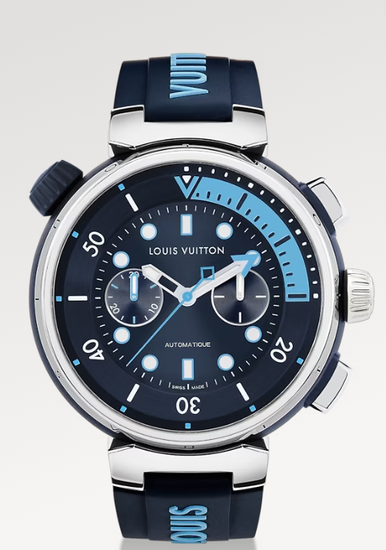

# Tambour Street Diver Chronograph, automatic, 46mm, steel

Bringing together the credentials of a traditional dive watch, the Tambour Street Diver collection embodies Louis Vuitton’s bold spirit in a selection of distinctive hues. Available in both its original form, which was awarded the GPHG Diving Prize in 2021, as well as a new chronograph version, it combines casual elegance and top-level performance.

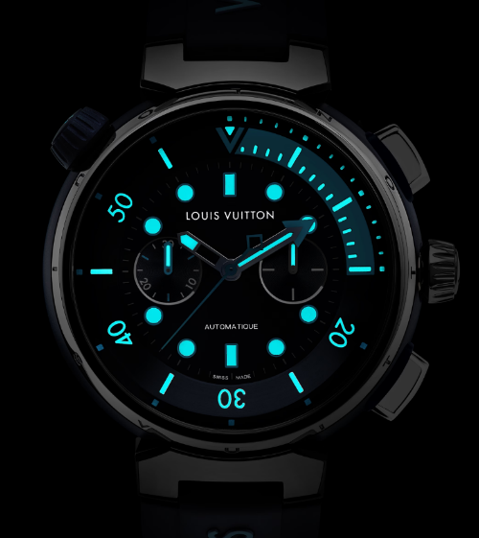

Vibrant Statement

Crafted for optimal versatility, the ultra-modern Tambour Street Diver distinguishes itself with a striking design that compliments an active city lifestyle. Topped with a color-contrasting crown that gears the dive bezel, its signature tapered case measures 44mm on the original model or 46mm on the chronograph.

Enhanced with a chronograph

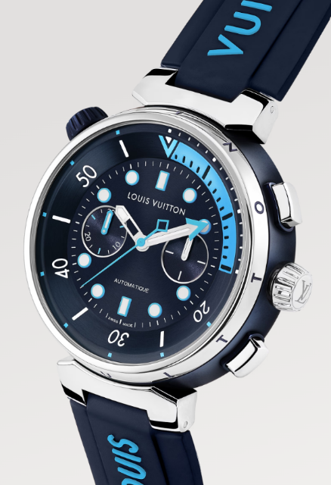Keeping the original sleek design and perfect legibility, the Tambour Street Diver Chronograph forges a powerful link between the case’s sculptural shape and top-level sports watch performance.